**Ex-16-1 #9:**

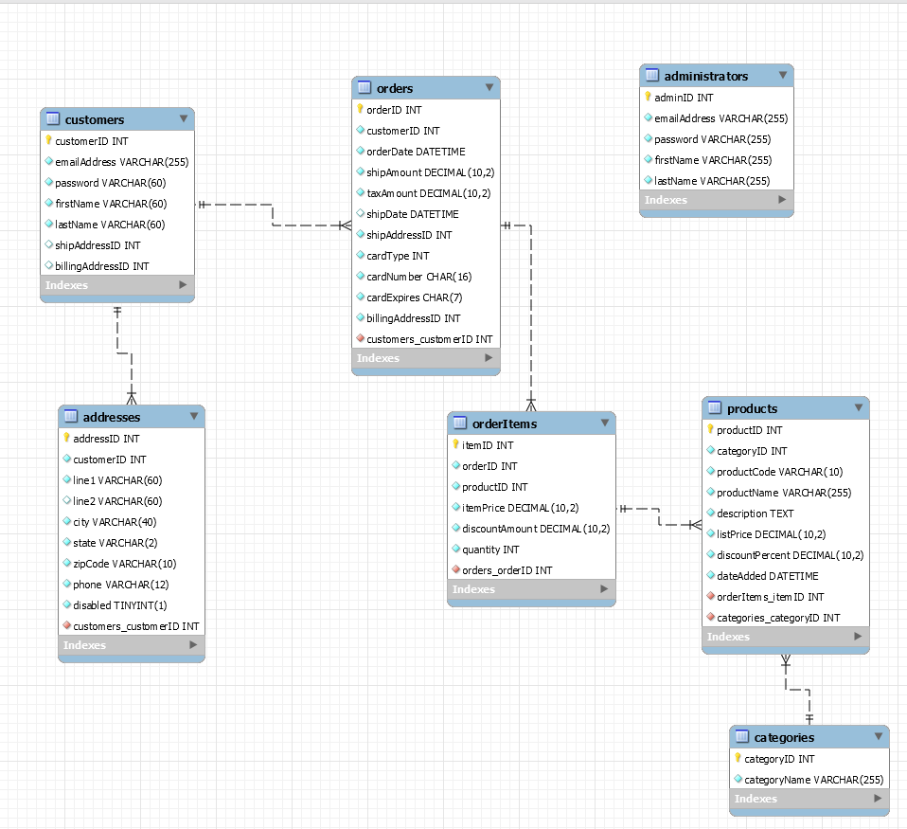

As you can see my diagram has the proper one to many relationships.

**Ex 16-2 #1:**

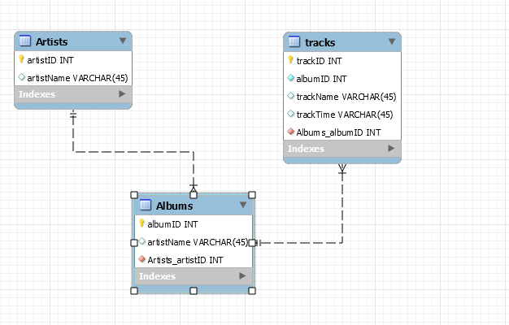

Here is my diagram with the relationships as shown.